User Guide

Contents

Welcome. 1

The Menu. 1

Option 1: Add an entry. 2

Option 2: Display names and numbers you have entered. 2

Option 3: Display all 20 records. 3

Option 4: Delete an entry. 3

Option 5: Delete all records. 3

Option 6: Search for a phone number. 4

Quitting the program. 5

Frequently Asked Questions. 5

### Welcome.

Welcome to the 1117627 phonebook for 20 names and numbers. Within this program you will be able to store up to 20 names and numbers. There are a host of features that this guide will take you through culminating in a FAQ section.

### The Menu.

Before anything happens you will be greeted by the main menu. As seen in figure 1.

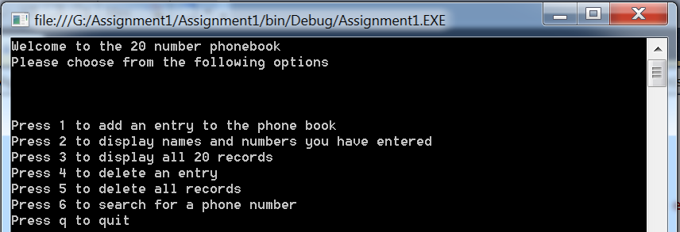

Figure 1

All you need to do is press the corresponding key to the action you wish to take.

### Option 1: Add an entry.

1. Select a box number from 0 to 19. This will indicate which field you wish to put the name and number in. If the box already contains a name and number you will be asked to confirm that you want to overwrite this.
2. Enter the first name and press enter. Repeat this action for the surname and the phone number.
3. You will see a confirmation of the data you have entered into the box. See figure 2.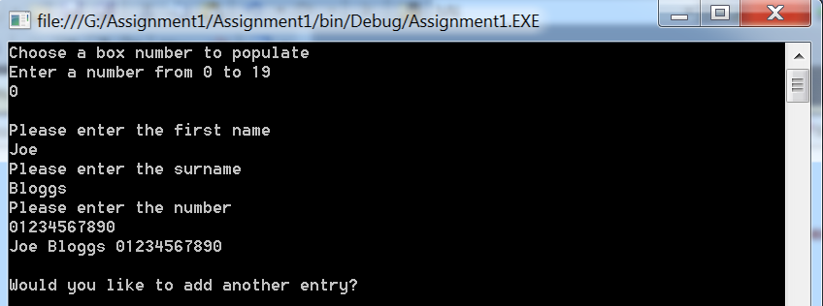

Figure 2

1. You will then be asked if you want to add another entry. Press ‘y’ if you do want to or ‘n’ to return to the main menu.

### Option 2: Display names and numbers you have entered.

This allows you to see all the names and numbers you have entered thus far. You will be instructed to press enter to return to the main menu. See figure 3.

### 

Figure 3

### Option 3: Display all 20 records.

By default all first names are entered as xx. All the surnames are entered as yy and all phone numbers are entered as 00. By choosing option 3 you will see all 20 boxes, including those that currently contain these default values. You will be instructed to press enter to return to the main menu. See figure 4.

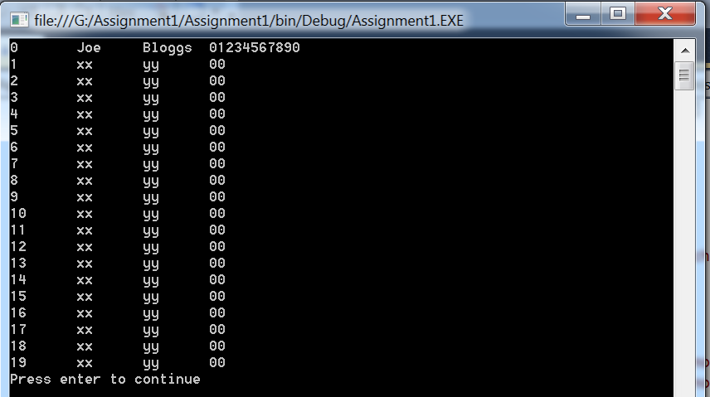

Figure 4

### Option 4: Delete an entry.

1. Select the box number you wish to reset to xx yy 00. Make sure you know the number beforehand by using option 2 or 3.
2. You will then see a confirmation message stating that the box has been reset to xx yy 00. See figure 5.

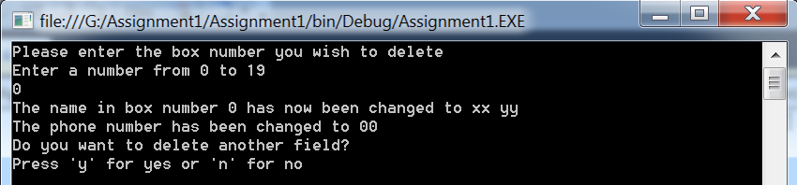

Figure 5

1. If you select yes you will be asked for another box number to reset.
2. If you select no you will return to the main menu.

### Option 5: Delete all records.

This will ask for confirmation that you really do want to reset all the records. If you press y for yes all fields will now be xx yy 00. A confirmation will be displayed. See figure 6.

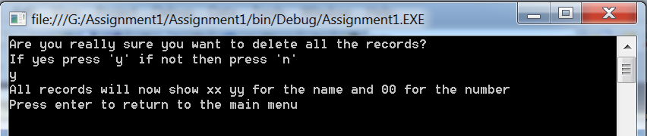

Figure 6

If you press n for no you will be taken back to the main menu and all the records will not be affected.

### Option 6: Search for a phone number.

1. Press 1 to search by first name, 2 by surname or 3 by whole name.
2. If searching by first name enter the name then press enter. All fields that match that first name will then be displayed. See figure 7.

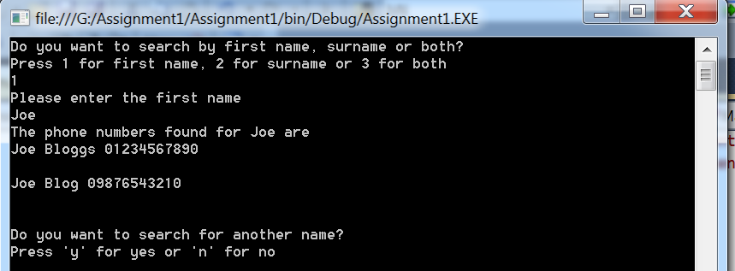

Figure 7

1. To search by surname you do the same by selecting option 2 and entering the surname you want to search by. See figure 8.

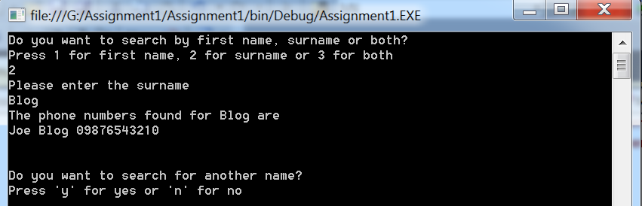

Figure 8

Note here how only Joe Blog was displayed, rather than both Joe Bloggs and Joe Blog.

1. Searching by the whole name will ask you to enter the first name then the surname. Only fields that match both the first name and surname will be displayed. See figure 9.

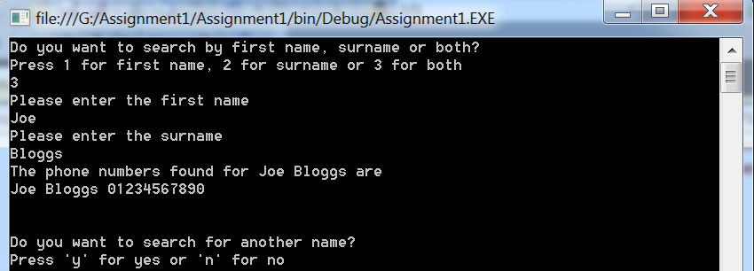

Figure 9

### Quitting the program.

To quit the program simply press q at the main menu. You will be asked for confirmation and either close the program if you press y, or it will return to the main menu if you press n. See figure 10.

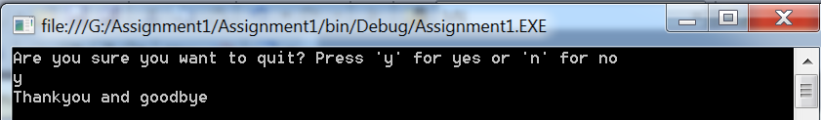

Figure 10

### Frequently Asked Questions.

1. Why, when I enter 20 is it telling me this is an invalid box number?

The box numbers run from 0 to 19 so there are 20 boxes but 19 is the last and 0 will be the first.

1. Why does the program tell me I have given an invalid selection when I press q, y or n?

Please make sure you are not using capitals. You may have the caps lock on and this will make the program think you are pressing Q rather than q. All options are in lower case where you need to make a selection by letter.

1. I’m pressing numbers on the numpad but it’s telling me this is an invalid selection. Why is this happening?

You may not have numlock on. Try pressing the numlock button, this should resolve the issue.

1. Why, when I search for a name does it not show the name I entered even though I know it’s there?

The search is case sensitive so the program will think that joe is different to Joe.